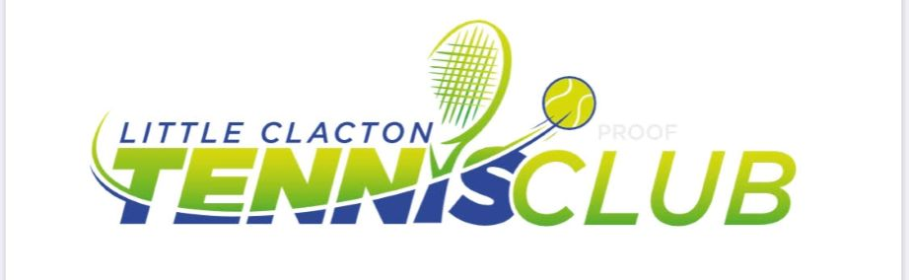

LITTLE CLACTON JUNIOR TENNIS COURSES – 2023
Dear Players/Parents,
Please find below a schedule for weekly Junior Courses leading up to the Easter holidays. If you have any queries as to the correct group, please contact me for clarification. I look forward to seeing everyone out on court.
Coach Chris

WEDNESDAYS – 4 to 5pm – LTA Youth Red Ball (5 to 8 yrs)
WEDNESDAYS – 5 to 6pm – LTA Youth Yellow Ball (12+ yrs)
Mar. 1st, 8th, 15th, 22nd, 29th. (5 sessions)
Members - £30, Non-members - £35

FRIDAYS – 4.30 to 5.30pm - LTA Youth Orange/Green Ball - (9 to 11yrs)
Mar. 3rd,10th,17th,24th, 31st. (5 sessions)
Members - £30, Non-members - £35

N.B. There will be minimums and maximums for each group to run.
To book onto a course please contact me:
chrisharris366@gmail.com / 07793 976913 / WhatsApp group ‘Lt Clacton Junior Tennis’
Payment can be made by cash at first session or bank transfer:
C H Harris Nationwide 07-02-46 48108248 (player name as reference please)

Little Clacton T.C., Whitegates Court, Holland Rd., Lt. Clacton. CO16 9FD

